**Semester 1 (Unit 3) Examination, 2019**

**Question/Answer Booklet**

**MATHEMATICS METHODS**

**Section One: Calculator-free**

Student Name/Number: ______________________________________________

Teacher Name: ______________________________________________

**Time allowed for this section**

Reading time before commencing work: five minutes

Working time for this section: fifty minutes

**Materials required/recommended for this section**

**To be provided by the supervisor:** This Question/Answer Booklet

Formula Sheet

**To be provided by the candidate:**

Standard items: pens (blue/black preferred), pencils (including coloured), sharpener,

correction fluid/tape, eraser, ruler, highlighters

Special items: nil

**Important note to candidates**

No other items may be taken into the examination room. It is **your** responsibility to ensure that you do not have any unauthorised notes or other items of a non-personal nature in the examination room. If you have any unauthorised material with you, hand it to the supervisor **before** reading any further.

**Structure of this paper**

|  |  |  |  |  |  |
| --- | --- | --- | --- | --- | --- |
| Section | Number of questions available | Number of questions to be answered | Working time (minutes) | Marks available | Percentage of exam |
| Section One: Calculator-free | 7 | 7 | 50 | 50 | 35 |
| Section Two: Calculator-assumed | 13 | 13 | 100 | 100 | 65 |
|  | | | | | 100 |

**Instructions to candidates**

1. The rules for the conduct of School exams are detailed in the School/College assessment policy. Sitting this examination implies that you agree to abide by these rules.
2. Write your answers in this Question/Answer booklet preferably using a blue/black pen. Do not use erasable or gel pens.
3. You must be careful to confine your answer to the specific question asked and to follow any instructions that are specified to a particular question.
4. Show all your working clearly. Your working should be in sufficient detail to allow your answers to be checked readily and for marks to be awarded for reasoning. Incorrect answers given without supporting reasoning cannot be allocated any marks. For any question or part question worth more than two marks, valid working or justification is required to receive full marks. If you repeat any question, ensure that you cancel the answer you do not wish to have marked.
5. It is recommended that you do not use pencil, except in diagrams.
6. Supplementary pages for planning/continuing your answers to questions are provided at the end of this Question/Answer booklet. If you use these pages to continue an answer, indicate at the original answer where the answer is continued, i.e. give the page number.
7. The Formula sheet is not to be handed in with your Question/Answer booklet.

**Section One: Calculator-free 35% (50 Marks)**

This section has **(seven)** **7** questions. Answer **all** questions. Write your answers in the spaces provided.

Supplementary pages for planning/continuing your answers to questions are provided at the end of this Question/Answer booklet. If you use these pages to continue an answer, indicate at the original answer where the answer is continued, i.e. give the page number.

Suggested working time: 50 minutes

**Question 1 (11 marks)**

(a) Differentiate with respect to (2 marks)

(b) Determine  Simplify your answer. (3 marks)

(c) Let  and 

Demonstrating clear use of the chain rule, determine  (3 marks)

(d) A particle moves in a straight line such that its displacement,  from the origin is given by  where  is measured in metres and  is measured in seconds. Use calculus to determine when the particle first stops. (3 marks)

**Question 2 (5 marks)**

Consider the function  shown below. The points, A, B, C, D, E, F and G each lie on the graph.

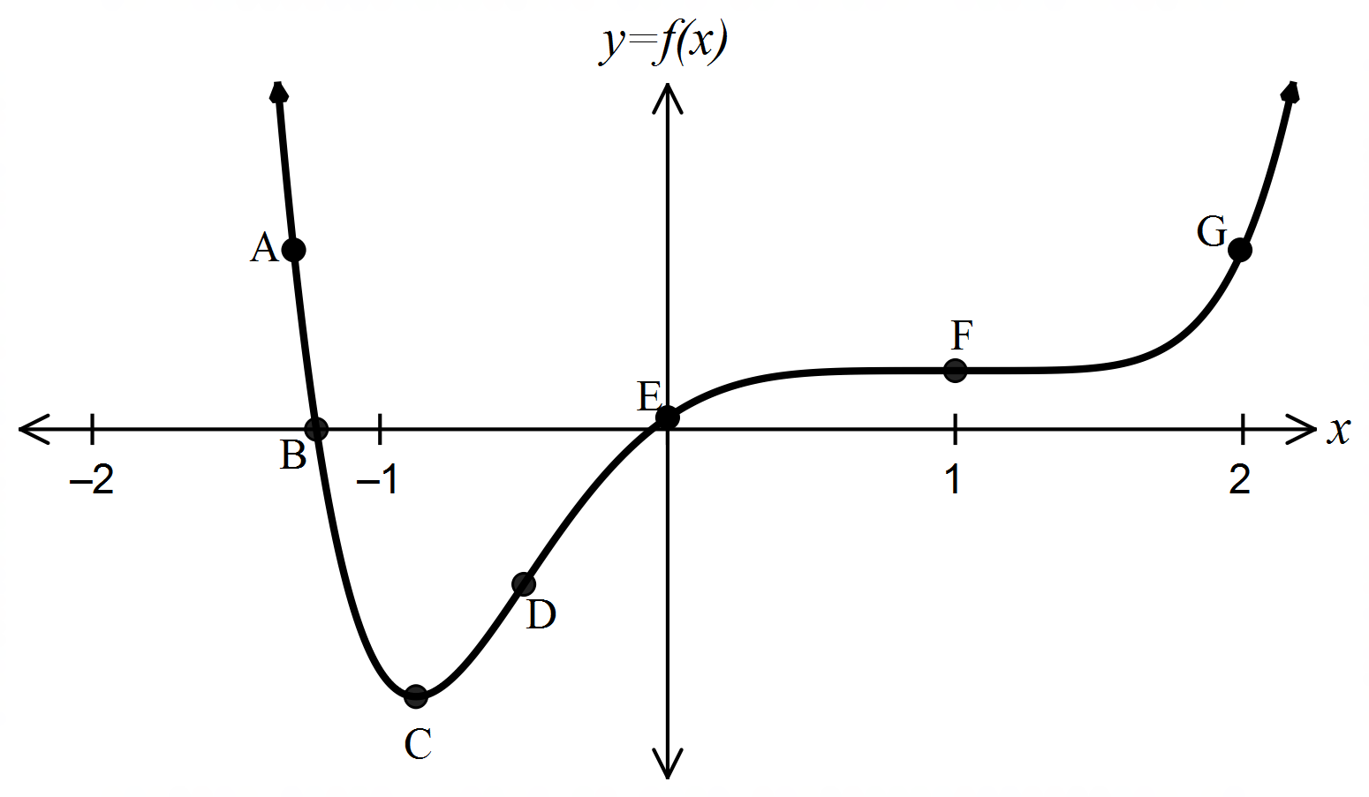

(a) Which point/s labelled on the graph above satisfy the following,

(i) a point of inflection occurs? (1 mark)

(ii)  and  (1 mark)

(iii)  is increasing and  (1 mark)

(iv)  and the function is concave up? (1 mark)

(b) Circle the graph below that represents . (1 mark)

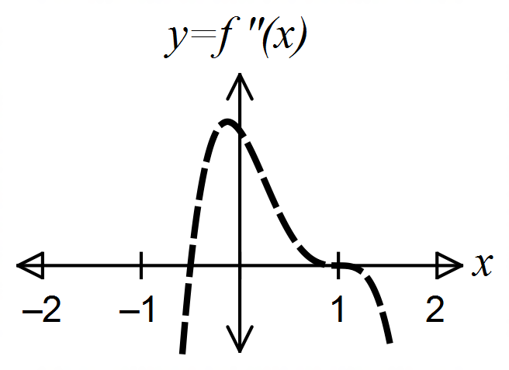

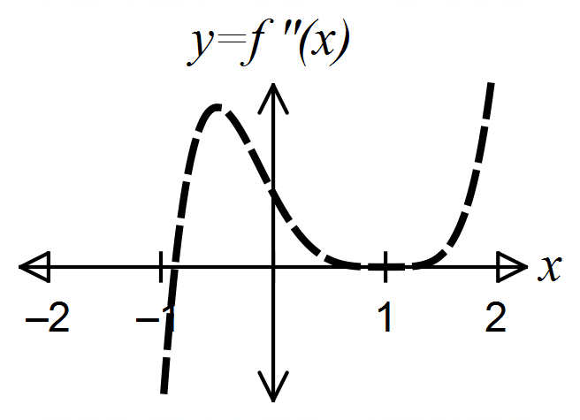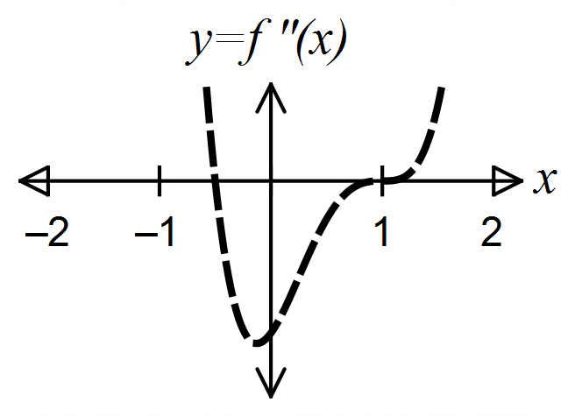

**Question 3 (4 marks)**

The graph of , over the domain  is drawn below.

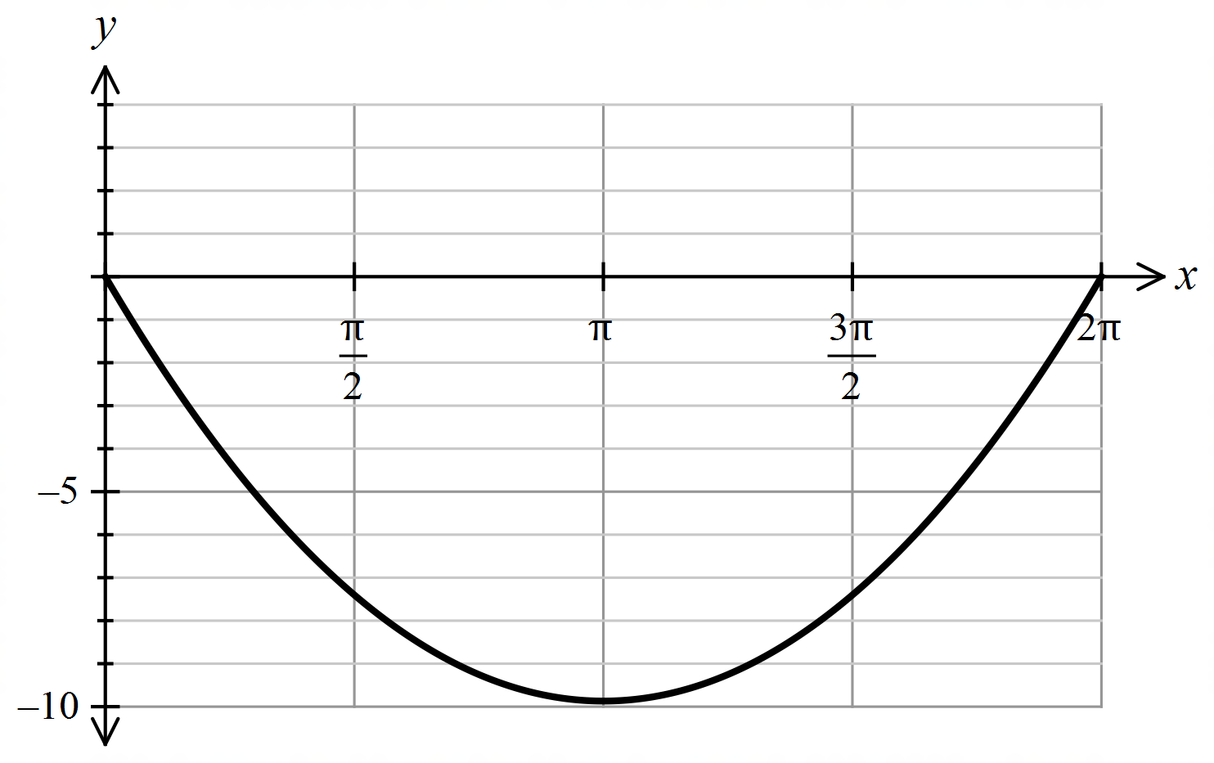

Calculate the exact areabetween the two curves**,**  and ,

for .

**Question 4 (9 marks)**

(a) Determine  (2 marks)

(b) Evaluate  (2 marks)

(c) Determine  if  (2 marks)

(d) Solve for  given . (3 marks)

**Question 5 (10 marks)**

Melinda and Matt are two students of Mathematics Methods. They are playing a board game using two unbiased dice. The person who throws the first double six gets to start the game.

Melinda and Matt decide to apply their knowledge of probability distributions to their game. Before Matt throws the two dice for the first time he defines a random variable  The random variable  is assigned the value 1 if two sixes are thrown and 0 otherwise.

1. Describe the distribution of  by stating its name, mean and variance.

(3 marks)

Melinda and Matt only have a short time to play the game so decide they will stop after each player has had 15 turns of rolling the dice.

Define the random variable  as the total number of double sixes that Melinda throws in her 15 rolls of the dice.

1. Describe the distribution of  including its parameters. (3 marks)

(c) State an expression to determine the probability that Melinda throws just one pair of double sixes in her 15 throws. (1 mark)

(d) State an expression to determine the probability that the total number of double sixes thrown by Melinda and Matt in their 15 rolls each of the dice is exactly 2 two given that Melinda threw at least one double six. (3 marks)

**Question 6 (4 marks)**

The graph below shows the function  for 

Rectangles of width  are also drawn.

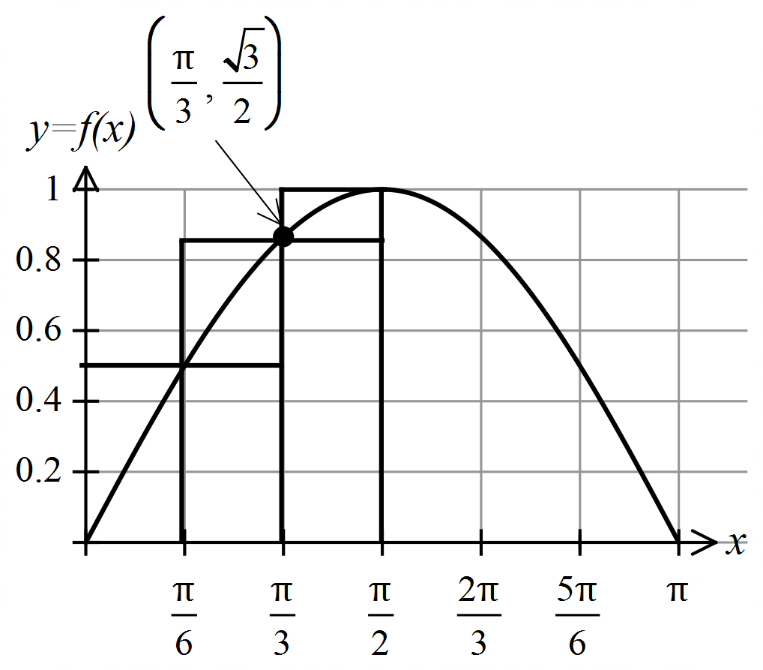

(a) Use these rectangles to determine

(i) an underestimate for the area under  from to (1 mark)

(ii) an overestimate for the area under  from  to (1 mark)

(b) Show that by using three trapeziums an estimate for the area under  from

 to is given by .

. (2 marks)

**Question 7 (7 marks)**

(a) Determine  where  (1 mark)

(b) Hence show clearly that  (3 marks)

(c) Hence or otherwise, evaluate  (3 marks)

Additional working space

Question number: __________________

© MAWA, 2019

This examination is Copyright but may be freely used within the school that purchases this licence.

* The items that are contained in this examination are to be used solely in the school for which they are purchased.
* They are not to be shared in any manner with a school which has not purchased their own licence.
* The items and the solutions/marking keys are to be kept confidentially and not copied or made available to anyone who is not a teacher at the school. Teachers may give feedback to students in the form of showing them how the work is marked but students are not to retain a copy of the paper or the marking guide until the agreed release date stipulated in the purchasing agreement/licence.

*Published by The Mathematical Association of WA*

*12 Cobbler Place, MIRRABOOKA 6061*